[-=

AstraZeneca 4Q25 Earnings | Readouts delayed for pivotal Calquence and surovatamig programs

Company: AstraZeneca  Drug: Calquence (acalabrutinib; BTKi), surovatamig (CD19xCD3 TCE) | Date: February 10, 2026  Source(s): press release, presentation, appendix
What happened:
- Although AstraZeneca did not directly address catalysts for ongoing phase 3 trials evaluating Calquence and surovatamig in DLBCL & FL, the Company quietly delayed readout guidance for numerous studies
- A readout for phase 3 ESCALADE has been delayed by 1 year, from >2026 to >2027
- Readouts for pivotal surovatamig trials, phase 1/2 SOUNDTRACK-B and phase 3 SOUNDTRACK-F1 have also been delayed by ~1 year, from >2026 to 2027 and >2027, respectively

Impact (CI PoV): MEDIUM
- Based on updated approval assumptions, EPKINLY-R-CHOP will have up to a half-year lead on ESCALADE in 1L DLBCL

Why it matters:
- Based on updated readout guidance, our internal assumptions for ESCALADE approval shifts ~1 year, to Q3 2027 (based on readout in Q1 2027 + 7 months for sNDA)
- Assumptions for surovatamig approval in 1L FL (Q4 2029; based on SOUNDTRACK-F1) and 3L+ DLBCL & FL (Q3 2028 & Q1 2029; based on SOUNDTRACK-B) do not change despite the updated readout guidance, as assumption methodology relies on historical benchmarking from study start to approval, not readout

Tell me more:
Trial Milestones & Updates:
- Calquence:
  - Ph3 ESCALADE (acalabrutinib + rituximab in 1L DLBCL)
    - Data now anticipated in 2027
    - Delayed from prior guidance of >2026
    - Primary intel at ASH indicated a readout was expected in ~H1 2026 (within the next 3-6 months); AZ booth as ASH included large ‘DLBCL forecasting’ screen highlighting the different subtypes and current outcomes suggesting Company may be gearing up for topline readout
- Surovatamig (AZD0486):
  - Ph3 SOUNDTRACK-F1 (AZD0486 + R in 1L FL)
    - Data now anticipated in >2027
    - Delayed from prior guidance of >2026
  - Ph3 SOUNDTRACK-D2 (AZD0486 + R-mini-CHOP in 1L e/f DLBCL)
    - Initiated in October 2025
    - Data anticipated in >2027
  - Ph2 SOUNDTRACK-B (AZD0486 in 3L+ FL/3L+ DLBCL)
    - Data now anticipated in 2027
    - Delayed from prior guidance of >2026
  - Ph1/2 SOUNDTRACK-E (AZD0486 mono or combo with acala/R-CHOP in B-cell malignancies)
    - Data anticipated in H2 2026 (reiterated)
  - Ph1 NCT04594642 (AZD0486 monotherapy in R/R B-NHL)
    - Data anticipated in H2 2026 (reiterated)
- AZD5492:
  - Ph1 TITANIUM (AZD5492 monotherapy in R/R B-cell malignancies)
    - Data anticipated in H2 2026 (reiterated)
- AZD4512:
  - Ph1/2 Lumi-NHL (AZD4512 monotherapy in R/R B-cell malignancies)
    - Data now anticipated in >2027
    - Delayed from prior guidance of >2026

Relevant slides:
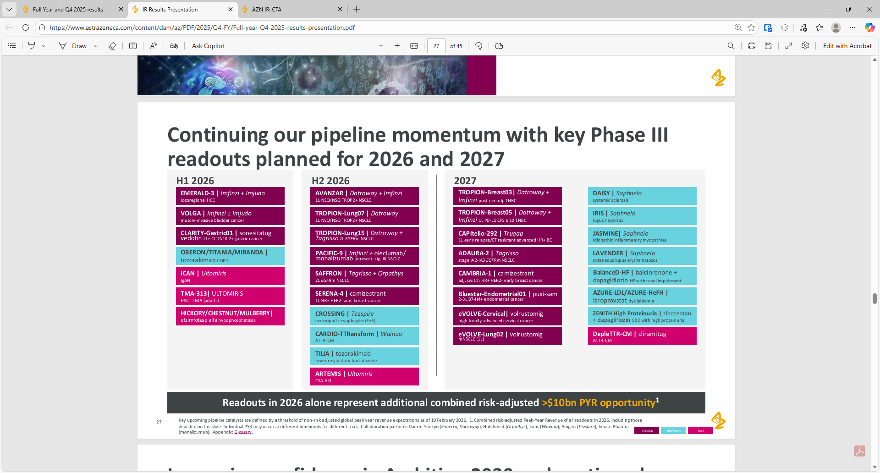
Phase 3 ESCALADE is not featured alongside other planned readouts for phase 3 trials in 2026-2027

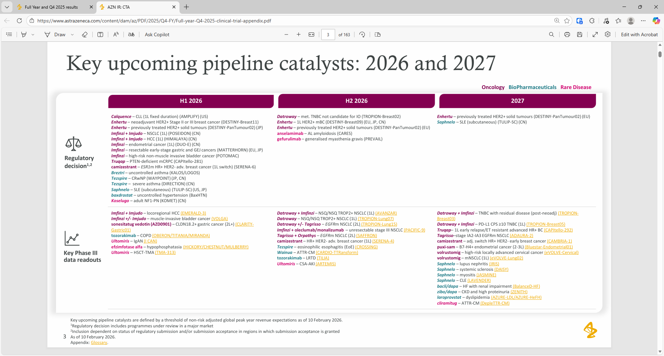
Readout guidance for ESCALADE and phase 3 surovatamig trials not noted in key upcoming catalysts
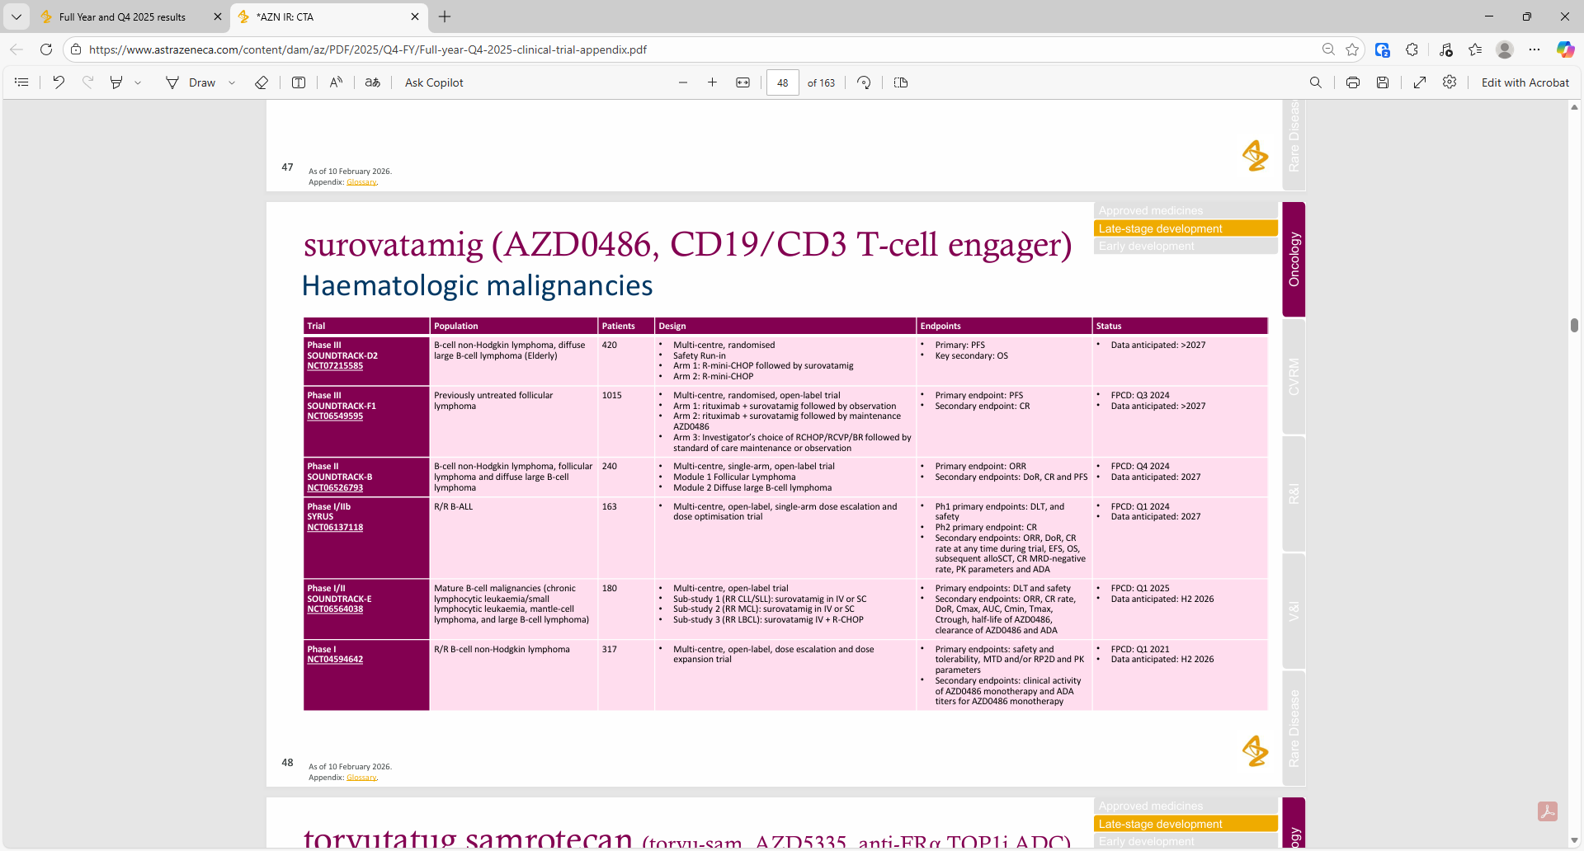

For questions, please reach out to:
International / OUS Affiliates: Harjit Bajwa
US: John Barkinge
Corporate Strategy, R&D and PCS: Aishwarya Jayagopal

Invite your colleagues to CI Edge | Manage Email Preferences | Unsubscribe

This document contains competitive intelligence collected via APEX/IMABI approved methods or vendors. We collect competitive intelligence consistent with industry standards and AbbVie policy. Not for commercial field distribution. Please reach out to Legal or OEC with any questions.

